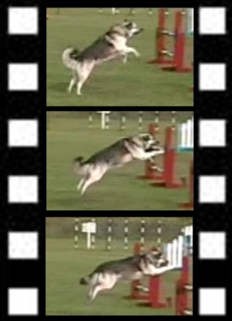
Every Dog's Day Video

www.everydogsday.com
video@everydogsday.com
2285 Torquay Avenue
Ottawa ON K2C 1J5
613-820-2968

Order Form
CSSA 2006 National Videos

Name: _________________________________________
Address: _________________________________________
_________________________________________
_________________________________________
Phone: _________________________________________

Email: _________________________________________

Format: DVD only

Agility: $30.43+$4.57 PST/GST $35 * ______ # of copies = ________
Conformation: $60.87+$9.13 PST/GST $70 * ______ # of copies = ________
Herding: $43.48+$6.52 PST/GST $50 * ______ # of copies = ________
Obedience: $60.87+$9.13 PST/GST $70 * ______ # of copies = ________

Entire event: $130.43+$19.57 PST/GST $150 * _____ # of copies = ________

Total: ________

Signature: ____________________________________

Make cheques out to Rhéal Nadeau. Prices includes shipping

